GitHub OIDC-Based Secure Deployment Architecture for EKS 1.36
Repository:
https://github.com/DevOps-Shack-Bootcamp/3-Tier-Java-NodeJS-MySQL-Project-NEW.git
GitHub organization: DevOps-Shack-Bootcamp
GitHub username: jaiswaladi246
GitHub Owner ID: 207828437
GitHub Repository ID: 1358786722
Important OIDC change: This repository uses GitHub's immutable OIDC subject format. The AWS trust policy must include the GitHub organization ID and repository ID, not only the organization/repository names.

1) Deployment design
We deploy to two namespaces:
• qa → deployment from the qa branch
• prod → deployment from the main branch

For isolation, use two GitHub OIDC IAM roles:
• GitHubActionsEKSQARole → EKS access only to namespace qa
• GitHubActionsEKSProdRole → EKS access only to namespace prod
Final authentication flow
1. GitHub Actions requests an OIDC token from GitHub.
2. AWS IAM validates the token audience and immutable subject.
3. The qa branch assumes GitHubActionsEKSQARole; main assumes GitHubActionsEKSProdRole.
4. The IAM roles can describe the EKS cluster and use ECR.
5. EKS access entries map each role to only its required namespace.
6. GitHub Actions runs aws eks update-kubeconfig and kubectl deploys the manifests.

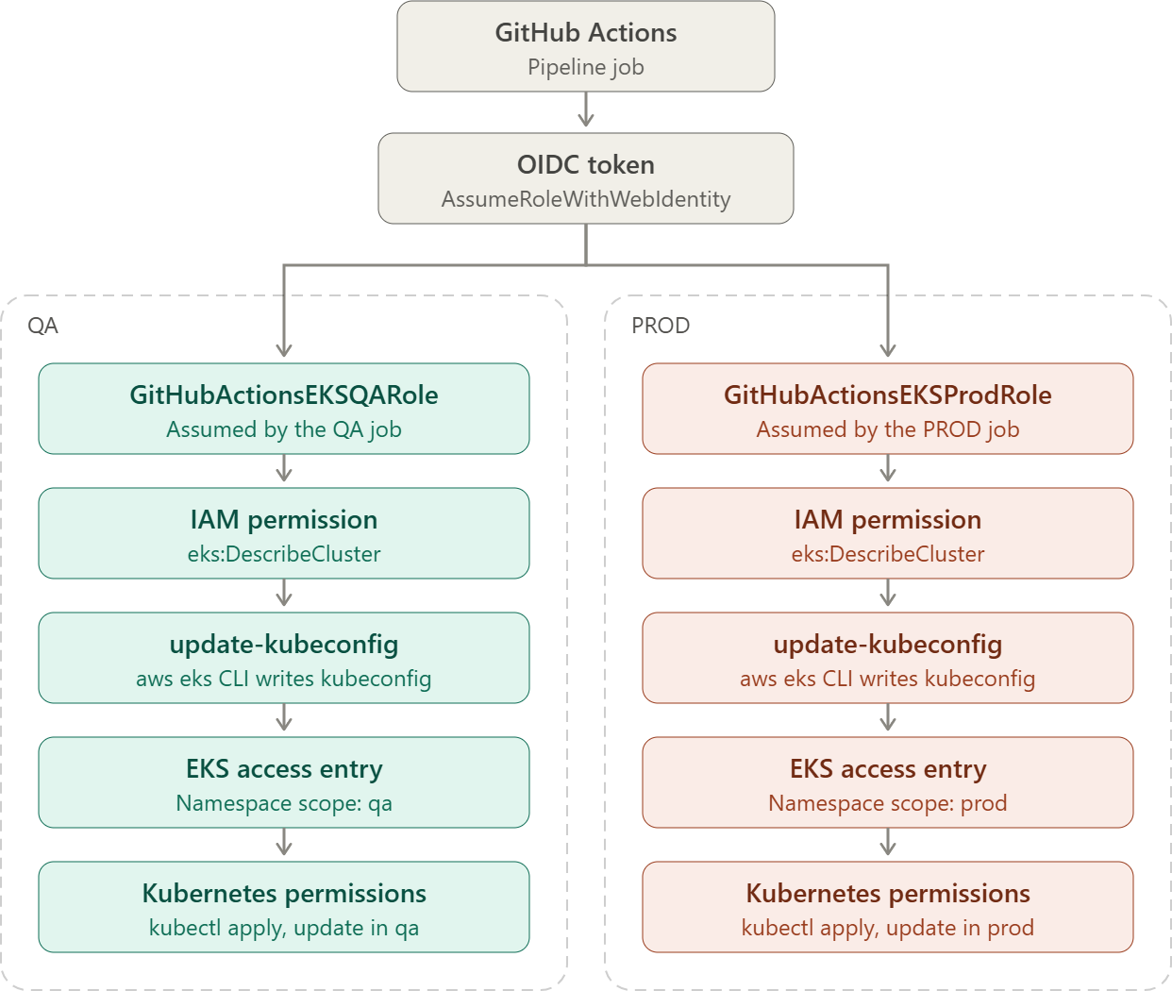
2) Preconditions
Before creating the OIDC roles, verify:
• AWS CLI is authenticated with an IAM principal that can manage IAM and EKS access entries.
• EKS cluster my-cluster is ACTIVE and running Kubernetes 1.36.
• Namespaces qa and prod exist.
• GitHub CLI (gh) is installed and authenticated because the repository is private.
aws sts get-caller-identity
aws eks describe-cluster --name my-cluster --region ap-south-1 --query "{status:cluster.status,version:cluster.version,authMode:cluster.accessConfig.authenticationMode}" --output json

We’re talking about the EKS cluster’s authentication mode—the setting that determines how IAM users and roles are granted access to Kubernetes in your cluster.
kubectl get ns
3) Install and authenticate GitHub CLI
Check whether GitHub CLI is already installed:
gh --version
If it is not installed on Windows, install it with winget:
winget install --id GitHub.cli --exact
Authenticate GitHub CLI:
gh auth login
Choose GitHub.com → HTTPS → Login with a web browser. Then verify:
gh auth status
Because this repository is private, verify that the authenticated account can read it:
gh repo view DevOps-Shack-Bootcamp/3-Tier-Java-NodeJS-MySQL-Project-NEW
If you get HTTP 401 / Bad credentials: Run gh auth logout, then gh auth login again, and finally gh auth status before continuing.

gh auth logout
gh auth login
gh auth status
4) Create / reuse the GitHub OIDC provider in AWS IAM
A GitHub OIDC Provider is the trust connection that allows GitHub Actions to authenticate to AWS without storing long-term AWS access keys.

GitHub Actions
|
| OIDC token
v
AWS IAM OIDC Provider
|
| "I trust tokens issued by GitHub"
v
IAM Role
|
V
Temporary AWS credentials

GitHub OIDC Provider
|
v
IAM Role
|
+-- Trust policy:
| repo = DevOps-Shack-Bootcamp/my-project
| branch = main
|
+-- Permission policy:
ECR
EKS
etc.

GitHub Actions
↓
Requests OIDC token from GitHub
↓
GitHub issues a short-lived signed token
↓
Workflow sends token to AWS STS
↓
AWS validates it using the GitHub OIDC Provider
↓
AWS checks IAM Role trust policy
↓
If everything matches
↓
AWS STS returns temporary credentials
↓
Workflow accesses AWS

Check whether the GitHub OIDC provider already exists:
aws iam list-open-id-connect-providers --query "OpenIDConnectProviderList[?contains(Arn, 'token.actions.githubusercontent.com')].Arn" --output text
If an ARN is returned, reuse it. Do not create another provider. If nothing is returned, create it:
aws iam create-open-id-connect-provider --url https://token.actions.githubusercontent.com --client-id-list sts.amazonaws.com
GitHub OIDC values:
• Provider URL = https://token.actions.githubusercontent.com
• Audience = sts.amazonaws.com
5) Automatically get GitHub Owner ID and Repository ID
Do this before creating the IAM trust policies. The same commands work for future repositories; only change the owner and repository name.
$GITHUB_OWNER = "DevOps-Shack-Bootcamp"
$GITHUB_REPO = "3-Tier-Java-NodeJS-MySQL-Project-NEW"
$REPO_INFO = gh api "repos/$GITHUB_OWNER/$GITHUB_REPO" | ConvertFrom-Json
$OWNER_ID = $REPO_INFO.owner.id
$REPO_ID = $REPO_INFO.id
Write-Host "Owner ID: $OWNER_ID"
Write-Host "Repository ID: $REPO_ID"
For this repository, the expected values are:
Owner ID: 207828437
Repository ID: 1358786722
6) Build the immutable QA and PROD OIDC subjects
$QA_SUBJECT = "repo:${GITHUB_OWNER}@${OWNER_ID}/${GITHUB_REPO}@${REPO_ID}:ref:refs/heads/qa"
$PROD_SUBJECT = "repo:${GITHUB_OWNER}@${OWNER_ID}/${GITHUB_REPO}@${REPO_ID}:ref:refs/heads/main"
Write-Host "QA subject: $QA_SUBJECT"
Write-Host "PROD subject: $PROD_SUBJECT"
For this repository, they resolve to:
QA: repo:DevOps-Shack-Bootcamp@207828437/3-Tier-Java-NodeJS-MySQL-Project-NEW@1358786722:ref:refs/heads/qa
PROD: repo:DevOps-Shack-Bootcamp@207828437/3-Tier-Java-NodeJS-MySQL-Project-NEW@1358786722:ref:refs/heads/main
Why this matters: Using the older subject repo:OWNER/REPO:ref:... causes sts:AssumeRoleWithWebIdentity to fail for this repository because AWS receives a different immutable sub claim.

7) Create QA and PROD IAM trust policy files
First get the AWS account ID:
$ACCOUNT_ID = aws sts get-caller-identity --query Account --output text
Create the QA trust policy:
@"
{
"Version": "2012-10-17",
"Statement": [
{
"Effect": "Allow",
"Principal": {
"Federated": "arn:aws:iam::${ACCOUNT_ID}:oidc-provider/token.actions.githubusercontent.com"
},
"Action": "sts:AssumeRoleWithWebIdentity",
"Condition": {
"StringEquals": {
"token.actions.githubusercontent.com:aud": "sts.amazonaws.com",
"token.actions.githubusercontent.com:sub": "$QA_SUBJECT"
}
}
}
]
}
"@ | Set-Content .\github-qa-oidc-trust.json
Create the PROD trust policy:
@"
{
"Version": "2012-10-17",
"Statement": [
{
"Effect": "Allow",
"Principal": {
"Federated": "arn:aws:iam::${ACCOUNT_ID}:oidc-provider/token.actions.githubusercontent.com"
},
"Action": "sts:AssumeRoleWithWebIdentity",
"Condition": {
"StringEquals": {
"token.actions.githubusercontent.com:aud": "sts.amazonaws.com",
"token.actions.githubusercontent.com:sub": "$PROD_SUBJECT"
}
}
}
]
}
"@ | Set-Content .\github-prod-oidc-trust.json
8) Create the IAM roles, or update them during repeat demos
First check whether each role already exists:
aws iam get-role --role-name GitHubActionsEKSQARole
aws iam get-role --role-name GitHubActionsEKSProdRole
If the roles do not exist, create them:
aws iam create-role --role-name GitHubActionsEKSQARole --assume-role-policy-document file://github-qa-oidc-trust.json
aws iam create-role --role-name GitHubActionsEKSProdRole --assume-role-policy-document file://github-prod-oidc-trust.json
If the roles already exist, do not recreate them. Update only the trust policies:
aws iam update-assume-role-policy --role-name GitHubActionsEKSQARole --policy-document file://github-qa-oidc-trust.json
aws iam update-assume-role-policy --role-name GitHubActionsEKSProdRole --policy-document file://github-prod-oidc-trust.json
Verify the final trust policies:
aws iam get-role --role-name GitHubActionsEKSQARole --query "Role.AssumeRolePolicyDocument" --output json
aws iam get-role --role-name GitHubActionsEKSProdRole --query "Role.AssumeRolePolicyDocument" --output json
9) Give the GitHub roles permission to describe the EKS cluster
aws eks update-kubeconfig requires eks:DescribeCluster.
@"
{
"Version": "2012-10-17",
"Statement": [
{
"Sid": "EKSDescribeCluster",
"Effect": "Allow",
"Action": ["eks:DescribeCluster"],
"Resource": "arn:aws:eks:ap-south-1:${ACCOUNT_ID}:cluster/my-cluster"
}
]
}
"@ | Set-Content .\eks-describe-cluster-policy.json
aws iam create-policy --policy-name GitHubActionsEKSDescribeClusterPolicy --policy-document file://eks-describe-cluster-policy.json
Repeat demo note: If create-policy says the policy already exists, reuse the existing policy ARN instead of creating another copy.

$EKS_POLICY_ARN = "arn:aws:iam::${ACCOUNT_ID}:policy/GitHubActionsEKSDescribeClusterPolicy"
aws iam attach-role-policy --role-name GitHubActionsEKSQARole --policy-arn $EKS_POLICY_ARN
aws iam attach-role-policy --role-name GitHubActionsEKSProdRole --policy-arn $EKS_POLICY_ARN
11) Ensure EKS authentication mode supports access entries
aws eks describe-cluster --name my-cluster --region ap-south-1 --query "cluster.accessConfig.authenticationMode" --output text
If it returns CONFIG_MAP, enable API access entries:
aws eks update-cluster-config --name my-cluster --region ap-south-1 --access-config authenticationMode=API_AND_CONFIG_MAP
Wait until the cluster becomes ACTIVE before continuing.
12) Create EKS access entries for QA and PROD roles
EKS Access Entry = tells the EKS cluster which IAM user or IAM role is allowed to access the Kubernetes API.
IAM Role
↓
EKS Access Entry
↓
"This AWS identity is allowed into this cluster"
EKS Access Policy = tells EKS what that identity can do inside Kubernetes.
Access Entry
↓
Access Policy
↓
Can view / create / update / delete resources
↓
Optionally limited to namespace: qa or prod
So in short:
Access Entry = WHO can access the cluster

Access Policy = WHAT they can do inside the cluster

$QA_ROLE_ARN = "arn:aws:iam::${ACCOUNT_ID}:role/GitHubActionsEKSQARole"
$PROD_ROLE_ARN = "arn:aws:iam::${ACCOUNT_ID}:role/GitHubActionsEKSProdRole"
aws eks create-access-entry --cluster-name my-cluster --region ap-south-1 --principal-arn $QA_ROLE_ARN
aws eks create-access-entry --cluster-name my-cluster --region ap-south-1 --principal-arn $PROD_ROLE_ARN
Repeat demo note: If an access entry already exists, do not recreate it. Continue to the access-policy association step.

13) Associate namespace-scoped EKS access policies
QA role → only qa namespace:
aws eks associate-access-policy --cluster-name my-cluster --region ap-south-1 --principal-arn $QA_ROLE_ARN --policy-arn arn:aws:eks::aws:cluster-access-policy/AmazonEKSEditPolicy --access-scope type=namespace,namespaces=qa
PROD role → only prod namespace:
aws eks associate-access-policy --cluster-name my-cluster --region ap-south-1 --principal-arn $PROD_ROLE_ARN --policy-arn arn:aws:eks::aws:cluster-access-policy/AmazonEKSEditPolicy --access-scope type=namespace,namespaces=prod
Verify:
aws eks list-associated-access-policies --cluster-name my-cluster --region ap-south-1 --principal-arn $QA_ROLE_ARN
aws eks list-associated-access-policies --cluster-name my-cluster --region ap-south-1 --principal-arn $PROD_ROLE_ARN
Expected:
GitHubActionsEKSQARole → AmazonEKSEditPolicy → namespace qa
GitHubActionsEKSProdRole → AmazonEKSEditPolicy → namespace prod
16) Final verification
aws iam get-role --role-name GitHubActionsEKSQARole --query "Role.AssumeRolePolicyDocument" --output json
aws iam get-role --role-name GitHubActionsEKSProdRole --query "Role.AssumeRolePolicyDocument" --output json
aws iam list-attached-role-policies --role-name GitHubActionsEKSQARole
aws iam list-attached-role-policies --role-name GitHubActionsEKSProdRole
aws eks list-access-entries --cluster-name my-cluster --region ap-south-1

